**ATA Cooled, Antonio Feed**

**Control Commands Manual**

**Matt Fleming, Minex Engineering, Ver 07c**

Other related files may be stored in folder “Testing”.

|  |  |  |  |
| --- | --- | --- | --- |
| Version | Date | Comment | Initials |
| Version 5a | 2018-11-05 | Released. ( still preliminary ) | MCF |
| Version 06 | 2019-03-17 | Slightly improved. | MCF |
| Version 07c | 2020-06-15 | Feed Firmware 5.4 | JSK |

**Table of Contents**

Introduction: 2

ATA Cooled Feed Image and Diagram: 3

Feed Control Board Commands: 4

Vacuum Control Commands: 5

Cryo Cooler Control Commands: 7

Favorite Control Commands & Setups: 8

Feed Control Program and Auto start: 9

How to run the auto start program : 9

Description of Start Program for Various Conditions: 10

Proposed Startup Program Routine: 11

Notes on fan speeds: 11

Control Items to Monitor: 12

Data Logging Program used at Minex: 13

Feed Control Board Help Command Examples: 14

How to Connect to Feed Control via the Rim Box: 14

Troubleshooting and Diagnostics ( incomplete ) 15

Feed Control Board Diagram and Photo: 16

Appendix A Typical Performance Charts 17

Appendix B Improvements Needed 19

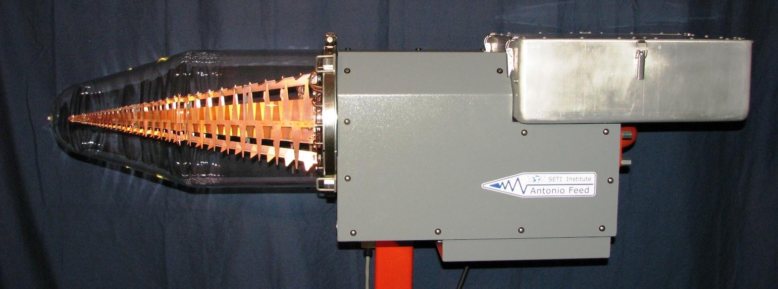

~

# Introduction:

These instructions should be read along with the following documents:

ATA Cooled Feed Manual Operation and Installation.

ATA Cooled Feed Development History.

There are 3 discrete control boards in the Feed Housing. They are: Feed Control, Vacuum Control & Cooler Control. There is also 1 control board in the Pax Box, but that is unrelated to this discussion. The Feed Control Board, designed by Rob Ackermann, coordinates all functions in the feed housing. It communicates with the Rim Box via RS-232, 19200 N 8 1. The Feed Control Board has a set of commands for monitor and control of devices in the feed, such as fan speed, temperature monitoring, etc. The board also passes several commands through to the Sunpower Cooler Control and the Pfeiffer Vacuum Control. Several tables of commands are shown in the pages that follow, one for each board.

The following notes apply.

* All commands are delivered to the Feed Control Board, but some are passed through to other controllers.
* No commands are identical among controllers. ( Ackermann, Pfeiffer, Sunpower )
* All commands to the Cooler Control Board are in upper case. ( Sunpower )
* All commands to the Vacuum Control Board begin with lowercase p. ( Pfeiffer )
* On a functional terminal screen, after command entry, the response will appear on the next line(s) below.
* We are now using the Feed Control Board relay to act as a thermostat input to the Cooler Control, 2019-02.
* More cooler commands are listed in the separate Sunpower controller manual. ( version 06 )
* More vacuum commands are listed in the separate Pfeiffer controller manual. ( version etc ? )
* On some commands a 0 before the decimal may be needed. ( not sure if this is still true )
* Colors used in this document have meaning and are intended to indicate the type of attention needed.

|  |  |  |  |
| --- | --- | --- | --- |
| **Examples of typical commands used on the 3 control boards** | | | |
| Item | Command | Response | Description ( direct to Feed Control Board )( always lower case ) |
| 1 | setfanpwm 30 | ok | Ackermann commands take any form except those of pass thru. |
| 2 | p316 | 22 | Pfeifer commands begin with a lower case p and are passed thru. |
| 3 | TC | TC\r\n65 | Sunpower commands are upper case and are passed thru. command is echoed and next line(s) contain answer |

Rob Ackermann has written a Data Logging Program in python (feed_test.py). It is used on a laptop at the command prompt. It opens a terminal program communicating with the feed via RS-232. One can also open a terminal program and type in commands

directly.

The logs generated from feed_test may be plotted with plot_logs.py. Several log files may be combined together (and optionally save it to pickle file) e.g. ./plot_logs.py -d --save plot_pickles/now.pkl logs/*log. Pickle files may be compared (currently temperature only) with compare_plots.py program.

~

# ATA Cooled Feed Image and Diagram:

|  |
| --- |
|  |

|  |
| --- |
|  |

# Feed Control Board Commands:

|  |  |  |  |
| --- | --- | --- | --- |
| **Feed Control Board Commands** ( Ackermann, direct ) ( via RS-232 19,200 N 8 1 ) | | | |
| Item | Command | Response | Description ( direct to Feed Control Board )( always lower case ) |
| 1 | help | big list | Display a list of supported commands. ( feed control only ) |
| 2 | help commands |  | Display a list of all commands. |
| 3 | help gt | specific | Example: how to get help with the "gt" command. |
| 4 | man | specific | alias for help |
| 5 | getfanpwm | 25 | Display fan power. ( % on time ) ( pulse width modulation ) |
| 6 | setfanpwm 30 | OK | Set new fan power. ( % on time ) ( or “setfanpwm auto” for temp reg ) |
| 7 | getfanspeed | 2420 | Display current fan speed. ( rpm ) ( 3000 rpm max speed ) |
| 8 | getcryoattemp | regulating | Display Cooler State, at setpoint temp. ( yes, no ) ( cooler pin 4 )( 5V=yes) |
| 9 | gettemp a0 | 28.1 | Display temperature, on control board. ( °C ) ( near ambient ) |
| 10 | gettemp a1 | 27.8 | Display temperature, Outside air. ( °C ) ( lower vent from amb ) |
| 11 | gettemp a2 | 27.8 | Display temperature, PAX air. ( °C ) ( PAX case exit air ) |
| 12 | gettemp a3 | 27.1 | Display temperature, Exhaust air. ( °C ) ( to amb ) ( a4 not used ) |
| 13 | gettemp a5 | 26.5 | Display temperature, Cooler rejection. ( °C ) ( near to fins ) |
| 14 | gettemp a6 | 25.5 | Display temperature, Cooler housing. ( °C ) ( back of housing )( 70 C max ) |
| 15 | gt a6 -f |  | Options use "gt" abbreviation or " -f" gives value in ( °F ) |
| 16 | getdiode  or gd | 68.0 | Display LNA temperature. ( Kelvin ) ( uses equation to calculate )  (T = -67792 X3 + 1661 X2 - 1794.7 X + 899.38 from excel )( Lakeshore 41 or 67 ? ) |
| 17 | gd -v | 0.527 | Display LNA diode voltage. ( _-v gives )( volts x.xxx ) |
| 18 | getvac  or gv | 1.2 E-05 | Display vacuum gauge. ( mbar )( equation )( if gauge is present )  ( p = 10^(1.667xU-d ) ( U volts ) ( d = 11.33 for mbar )  Similar to p340 when using Pfeifer DCU. ( 1 atm = 1.013 E+3 mbar )  also message "under range" "over range" "sensor error" |
| 19 | gv -v |  | Display vacuum gauge voltage. ( 5 volts = 1.0E-3 ) |
| 20 | getaccel | table | Display accelerometer data in a 3 x 4 matrix. since last call. ( g )  3 rows, X, Y, Z, and 4 columns, min, mean, stddev, max. 1 sec running avg. |
| 21 | getaccel -d x 100 | string | Dump samples, x axis, 100 count. ( 1 to 400 ) ( 400 / second ) |
| 22 | getrelay | 0 | Display relay state |
| 23 | setrelay 1 |  | Set Relay, 1 = closed, 0 = Open. ( future use )( maybe gauge ) |
| 24 | getfeedstartmode | string | Displays manual or auto. |
| 25 | setfeedstartmode | OK | manual or auto. ( if auto selected, use reset to start auto program ) |
| 26 | getcryoattemp | Y –or- N | Display Y for regulating or N for not regulating. |
| 27 | get24v | 23.9 | Display 24 VDC actual measured. |
| 28 | get48v | 47.9 | Display 48 VDC actual measured. ( not connected ) |
| 29 | getversion | 5.3 | Display current firmware version. |
| 30 | reset | string | Resets the program. ( this will take 1 minute, then 1 minute to fix all com ) |
| 31 | restart | string | Resets the program (much faster, by setting a reset bit) |
| 32 | osc | integer | Don’t know this one. Seems to control external oscillator and changing that value will invalidate many constaints in the code |
| 33 | bootloader |  | Don’t know this one. (seems to reload firmware to bootloader state, where external memory may be flashed) |
| 34 | stty –or- rimbox |  | Changes line separator to ‘|’ instead of ‘\r\n’ for virtual tcpip |
| 35 | ls –or- dir | list | Display the contents of a directory. ( example: “dir” ) |
| 36 | cat –or- type | text | Display the contents of a file. ( example: “type log.txt” ) |
| 37 | minex –or- ht  –or- hyperterminal |  | From the command prompt in the correct directory of a laptop. |
| 38 | aa ON --or-- accelonesec ON | table* | Starts calling getaccel every second. |
| 39 | aa OFF --or-- accelonesec OFF | table* | invalidates aa ON |
| 40 | rs | string | apparently test command to see if rs232 is working properly |
| 41 | state --OR-- getstate | 0x00 | returns the auto start state machine state (and auto start error numbers),  8 LSB are autostart states, rest are error numbers. see help state to get information about every bit meaning |
| 42 | getswitchtemp | 130.0 | returns autostart diode switch temp (from power to temperature control mode) |
| 43 | setswitchtemp | OK | update and save to file the new switch temperature. If “OK” is not returned, it means that the temperature was not updated |
| 44 | autostart | OK | sets autostart flag to true. In most cases (e.g. not in error 004) it should start the startup routine. Also, shortens current timeout to at max 3 s. (e.g. turbopump cycle if called during that state) |
| 45 | shutdown | OK | sets the shutdown flag. In most cases (e.g. not in error 004) it should start the shutdown routine (heat up) |
| 46 | getbackingtime | 20 | display backing pump runtime in autostart routine |
| 47 | setbackingtime | OK | update and save to file the new backing pump runtime [minutes]. If “OK” is not returned, it means that the time was not updated |
| 48 | getstandbytime | 20 | display standby turbo runtime in autostart routine |
| 49 | setstandbytime | OK | update and save to file the new standby turbo runtime [minutes]. If “OK” is not returned, it means that the time was not updated |
| 50 | getturbotime | 10 | display full turbo throttle runtime in autostart routine |
| 51 | setturbotime | OK | update and save to file the new full turbo throttle runtime [minutes]. If “OK” is not returned, it means that the time was not updated |
| 52 | clrerr -or- clearerror | OK | clear autostart status errors |

Do not allow cooler temperatures "a6" to exceed 70 to 75 C.

~

# Vacuum Control Commands:

|  |
| --- |
| **Vacuum Control TC-110 Commands** ( Pfeiffer, passed through Feed Control Board ) ( prefix p ) ( RS-485 9,600 N 8 1) |
| **-------- Initial programmed Settings are Shown in Column 2 ------- Other Options Shown in Column Last ----------** |

|  |  |  |  |
| --- | --- | --- | --- |
| Item | Command | Response | Description ( always lower case ? ) |
| 1 | p009=1 | 111111 | **Set acknowledge error.** 1 = acknowledge, ( data type 0 for true false )  note: Allows station start if p010=1 but stopped due to fault, maybe p010=0 first. |
| 2 | p010=0 | 000000 | **Set pumping station.** turbo & diaphragm. ( takes 8 to 10 min to wind down )  0 = off. ( setting is preserved at power down and applied at next power up )  1 = on. ( clears error )( starts Diaphragm, starts Turbo if p023=1 ) |
| 3 | p002=000000 | 000000 | **Set turbo standby on / off.** for turbo motor, In standby mode turbo will spin with lower RPM (controlled by p717) and lower power. Prefered way instead of switching it off completely |
| 4 | p023=1 | 111111 | **Set turbo on / off.** for turbo motor only. ( not the same as Station On )  0 = off. ( technically 000000 ) & 1 = on. (technically 111111 )( but 0 & 1 work ) |
| 5 | p024=000 | 000 | **Set D pump speed high / low.** Set Cfg D01, Output, ,  0 = Rot speed switch point. ( see p701, turbo at 90% )  9 = always 0, MVP-006 pin 8 = open, high speed, 3000 rpm.  10 = always 1, MVP-006 pin 8 = 24 VDC, low speed 1000 rpm. ( seasoned )  13 = follow backing mode. ( see p025 )( MVP-006 DIP Sw 2 set to off )  note for 13, Control is equal to p010 and p025. ( 111111 and 001 ) |
| 6 | p025=001 | 001 | **Set D pump intermittent.** backing pump.  0 = continuous. ( uses p024=9 or p024=10 )  1 = intermittent. ( assumes p024=13 ) ( uses settings p710 & p711 )  2 = delayed switch-on. ( not used for our process ) |
| 7 | p035=003 | 003 | **Set D pump on / off / backing.** Set Cfg Acc A1, Accessory , ,  3 = backing pump.  6 = always 0, MVP pin 3/10 = open, diaphragm pump off.  7 = always 1, MVP pin 3/10 = 24 VDC, diaphragm pump on. |
| 8 | p027=001 | 001 | Set gas load. 1 = light gas. |
| 9 | p700=000120 | 000120 | Set value run-up time. ( min ) ( 1 to 120 )( maybe need shorter ) |
| 10 | p701=000090 | 000090 | Rotation speed switchpoint 1. ( % turbo full speed, ) ( used by p024 ) |
| 11 | p707=010000 | 010000 | Set value in rotation speed setting mode. ( % full speed 100.00 = 90,000 rpm ) |
| 12 | p708=070 | 070 | Set value power consumption. ( % full power, 100% = 110w unit, 90w at p316 ) |
| 13 | p710=000014 | 000014 | Set point diaphragm intermittent on. ( motor off ) ( watts )( based on p316 ) |
| 14 | p711=000024 | 000024 | Set point diaphragm intermittent off. ( motor on ) ( watts )( based on p316 ) |

|  |
| --- |
| **Vacuum Control TC-110 Commands related to DCU 002** ( only relevant for Pfeiffer hand held unit attached ) |

|  |  |  |  |  |
| --- | --- | --- | --- | --- |
|  | p794=001 | 7 | 001 | Set extended parameter set. ( 0 = basic, 1 = extended set, like p710 etc ) |
|  | p738=PKR2xx | 4 |  | Set type of gauge. ( PKR251 Combined Pirani & Cold Cathode )( DCU page 8 ) |
|  | p340 | 7 | 1.2 E-4 | Display pressure from gauge. ( mbar )( only Pfeiffer DCU ) ( p738 gauge type ) |

|  |  |  |  |  |  |
| --- | --- | --- | --- | --- | --- |
| Data Type. ( “T” in the table above ) | | |  | Note: ECU indicator LED lights mean the following: | |
| Type 0 | for true false, | 000000 or 111111. |  | Green flashing | = power on. |
| Type 1 | positive 6 place integer | 000000 to 999999 |  | Green Solid | = station on. |
| Type 2 | positive 6 place integer, | 001571 is 15.71 , decimal 2nd & 3rd place. |  | Yellow Solid | = Warning. ( usually wrn117 ) |
| Type 4 | symbol chain 6 places | TC_400 |  | Red solid | = Malfunction. ( usually err117 ) |
| Type 7 | positive 3 place integer. | 000 to 999 |  | Note: To extend life, delay p023=1 until 1.2 E+1 mbar. | |

|  |
| --- |
| **Vacuum Control TC-110 Values to Monitor, Thresholds, Warnings & Errors. ( See page 46 Pfeiffer Manual )** |

|  |  |  |  |
| --- | --- | --- | --- |
| Item | Monitor | Returns |  |
| 10 | p303 | wrn117 | Display error messages, ( also use p360 to p369 for history ) |
| 11 | p304 | 0 | Display Excess Temp Electronics. ( 0 = no, 1 = yes ) |
| 12 | p305 | 0 | Display Excess Temp Turbo. ( 0 = no, 1 = yes ) |
| 13 | p310 | 000183 | Display Turbo current consumption. ( amps ) ( 000183 = 1.83 ) ( data T2 ) |
| 14 | p311 | 85 | Display Station operation ( hours )( 0 to 65535 ) |
| 15 | p315 | 001500 | Display Turbo speed, nominal. ( Hz ) ( 1500 Hz = 90,000 rpm )( x6 ) |
| 16 | p316 | 000022 | Display Turbo power consumption. ( watts )( 77 max )( 14 good ) |
| 17 | p326 | 000034 | Display Electronics control board temperature. ( °C xx.x ) ( tenths ? ) |
| 18 | p330 | 000035 | Display Turbo bottom temperature. ( °C) ( most sensitive to fan ) |
| 19 | p342 | 000039 | Display Turbo bearing temperature. ( °C) ( no tenths from Pfeiffer ) |
| 20 | p346 | 000042 | Display Turbo motor temperature. ( °C ) ( error 117 ) ( 100 is hot ) |
| 21 | P360 | Err006 | Display Error History, position 1. ( p361 gives position 2, p362 gives position 3, etc ) |
| 22 | p398 | 90016 | Display Turbo speed, actual. ( rpm )( 90,000 nom )( 90,600 bad, reset p023 ) |

|  |  |  |  |  |  |  |
| --- | --- | --- | --- | --- | --- | --- |
| Item | Monitor | Warning | Value | Error | Value | Description see page 57 manual. |
|  | p701 |  |  | Err006 |  | Run-up time error. ( Err also called malfunction ) |
|  | p326 | Wrn044 | 80 | Err044 | 85 | Excess Temp Electronics general, ( °C )( better cooling ) |
|  | p346 | Wrn045 | 115 | Err045 | 120 | Excess Temp Motor. ( °C ) |
|  | p330 | Wrn117 | 55 | Err117 | 60 | Excess Temp Pump bottom. ( °C ) ( most common sensitive ) |
|  |  | Wrn118 |  | Err118 |  | Excess Temp Electronics Power Stage. ( °C ) |
|  | p342 | Wrn119 | 55 | Err119 | 60 | Excess Temp Bearing. ( °C ) |
|  |  |  |  |  |  | Warning value will issue a warning, yellow LED. |
|  |  |  |  |  |  | Error value will change operation or shutdown sys, red LED. |

~

# Cryo Cooler Control Commands:

|  |  |  |  |
| --- | --- | --- | --- |
| **Cooler Control Board Commands** ( Sunpower, passed thru Feed Control Board ) ( via RS-232 4,800 N 8 1 ) | | | |
| Item | Command | Response | Description ( always upper case ? ) |
| 1 | SET TSTATM=1 | 001.00 | How to use thermostat, 0 = disable , 1 = use IO input 3. ( via relay ) |
| 2 | TSTAT |  | Display status of thermostat, If M=1 |
| 3 | SET SSTOPM=1 * | 0 change? | Set Soft Stop Mode. ( 0 = stop via SSTOP , 1 = stop via pin 5. Pin 5 is unused ) |
| 4 | SET SSTOP=1 * | 1 | Set Soft Stop. ( 0 = restart motor, 1 = stop motor ) |
| 5 | SET MAX=210 * | 210 | Set Max user defined power. ( watts ) Not PWOUT. Factory < 240. |
| 6 | SET MIN=100 * | 80 | Set Min user defined power. ( watts ) Not PWOUT. Factory > 70. |
| 7 | SET PID=2 * | 002.00 | Set control to temperature mode. (0 = power, 2 = temp) |
| 8 | SET TTARGET=65 * | 065.00 | Set cold-head temp target to number. ( Kelvin ) ( risk if below 60 ) |
| 9 | SET PWOUT=200 * | 200.00 | Set power target to number. ( watts ) ( while in PID mode 0 ) |
| 10 | TC | 65 (065.00) | Display Temperature Coldhead. ( Kelvin ) ( risk if below 60 ) |
| 11 | P | 210 | Display current power. ( watts ) |
| 12 | E | 240  70  120 | Max allowable power. ( watts ) ( varies with cold, usually 240 )  Min allowable power. ( watts ) ( never less than 70 )  Current power. ( watts ) ( usually < 240 during regulation ) |
| 13 | SHOW MX | 80  210 | Display Min & Max. ( watts ) |
| 14 | STATE | list | Display status list of 14 commanded states. ( see manual ) |
| 15 | RESET=F | RESETTING | Resets all parameters to factory default. |
| 16 | ERROR  Over Current  Jumper error  Serial Error  Memory Error  Watchdog Error  Temp Sensor Error | 000 001  000 010  000 100  001 000  010 000  100 000  100 001 | Display error messages. ( both LEDs are flashing repeatedly )  Red & Grn LED Flash 1 time, then pause then repeat.  Red & Grn LED Flash 2 times, then pause then repeat.  Red & Grn LED Flash 3 times. ( Baud 4800, None, Data 8, Stop 1 )  Red & Grn LED Flash 4 times. ( Non-volatile Memory )  Red & Grn LED Flash 5 times.  Red & Grn LED Flash 6 times, ( coldhead, test sensor at connector )  Multiple Errors, Over Current & Cold Temp Sensor. |
| 17 | SET PWOUT=70 | 70 | Set cryo power. only valid when PID=0 |

*1 To display current value for most commands, type the command without " =number".

Example: SET TTARGET displays 065.00 ( note space between SET and TTARGET )

*2 PID means proportional, integral, differential, a control method.

|  |  |  |
| --- | --- | --- |
| **Cryo Cooler Notes** | | |
|  | Operation | Cooler should start within 11 seconds of power on for SSTOP=0. |
|  | Conditions | Needs 48 VDC +/- ? Needs 6 watts minimum thermal load.  Needs 100 cu-ft/min air. Cools best with vacuum better than 1.0E-4 mbar. |
|  | Red LED on | Unit in cool down mode, above Set Point Temp. |
|  | Grn LED on | Unit regulating within 0.5 Kelvin of Set Point Temp. ( pin 4 high ) |
|  | Inhibit motor on/off | see feed control board relay. ( maybe )( pin 3 or 10 at 5 VDC to pin 5 soft stop ) |
|  | Do not operate without at least 100 cfm airflow. That means 24 VDC must be present. | |
|  | Do not allow cooler temperatures to exceed 70 to 75C. The motor winding bobbin will degrade or melt. | |
|  | Do not allow TC below 65 Kelvin. The unit may backdrive when power is removed. This action may damage the unit. It is an audible knocking sound. Repower the unit and set temperature higher before removing power. Feed -004 seems to do this easily, so it has TTARGET set to 70 Kelvin. | |

# Favorite Control Commands & Setups:

|  |
| --- |
| **Feed Control Initial Setup:** |

|  |  |  |  |
| --- | --- | --- | --- |
| Item | Command | Response | Description ( always lower case ? ) |
| 1 | p010=0 | 000000 | Set pumping station, 0 = off. ( also clears errors ? ) |
| 2 | p023=0 | 000000 | Set turbo on / off, 0 = off. |
| 3 | p024=000 | 000 | Set D pump speed high / low, 000 high to low at Rot speed switch point. |
| 4 | p025=000 | 000 | Set D pump intermittent, 000 cont, 001 int. ( 1 no longer used, see p710 p711 ) |
| 5 | p035=003 | 003 | Set D pump 007 on, 006 off, 003 backing pump mode. |
| 6 | p027=001 | 001 | Set gas load. 1 = light gas. |
| 7 | p700=000020 | 000020 | Set value run-up time. ( min ) ( 1 to 120 )( maybe need shorter ) |
| 8 | p701=000090 | 000090 | Rotation speed switchpoint 1. ( % turbo full speed, )( 90%)( used by p024 ) |
| 9 | p707=010000 | 010000 | Set value in rotation speed setting mode. ( % full speed 100.00 = 90,000 rpm ) |
| 10 | p708=070 | 070 | Set value power level. ( % full power, 100% = 110w unit, 90w at motor p316 ) |
| 11 | p710=000014 | 000014 | Set point diaphragm intermittent on. ( motor off ) ( watts )( based on p316 ) |
| 12 | p711=000024 | 000024 | Set point diaphragm intermittent off. ( motor on ) ( watts )( based on p316 ) |
| 21 | SET SSTOPM=0 | 0 | Set Soft Stop Mode, 0 for software SSTOP. ( 1 = stop via pin 5 for future use ) |
| 22 | SET SSTOP=1 | 1 | Set Soft Stop, 1 for stop motor. |
| 23 | SET PID=2 | 002.00 | Set control, 2 for temperature mode. |
| 24 | SET TTARGET=65 | 065.00 | Set cold-head temp target, 65 Kelvin. |
| 31 | getfeedstartmode | auto |  |

|  |
| --- |
| **Vacuum Control TC-110 The preferred Start Up Routine:** |

|  |  |  |  |  |
| --- | --- | --- | --- | --- |
| Time  (min) | Cmd | Value | Vacuum  (mbar) | Description |
| assume | p010=  p023=  p025=  p035= | 0  001  001  003 |  | Set pumping station, off. ( maybe p009=1 clear errors )  Set T pump for start with station on. ( T = Turbo )  Set D pump intermittent on. ( no longer used )( was set at 90 min mark )  Set D pump power. ( backing pump ) ( usually does not change ) |
| setup | p023=  p024=  p025= | 001  009  000 | 1.0 atm | Set T pump off.  Set D pump speed high. ( runs for 60 to 80 minutes )  Set D pump Intermittent off ( Continuous ) ( or set 001 now not later ) |
| 00 | p010= | 1 | 1.0 atm | Set pumping station on. ( D pump high speed if p024=000 & p035=003 ) |
| 08 |  |  | 7.0 E+2 | Gauge begins to read a value between 9.0 & 4.0 E+2. ( if available ) |
| 40 |  |  | 1.2 E+1 | Typical vacuum at this time. ( might be able to start turbo here ) |
| 60 | p023= | 1 | 3.0 E+0 | Set T pump on. ( begin run up time ? ) ( only works if p010=1 ) |
| 64 |  |  | 1.0 E -5 | Turbo run up complete. ( usually 4 to 6 minutes ) ( 12 watts at 75 min ) |
| 80 | p024= | 000 |  | Set D pump speed low. ( using turbo rotation speed switch ) |
| 90 | p025= | 001 | ?.0E -5 | Set D pump intermittent on. ( optional depending on conditions) |

|  |
| --- |
| **Vacuum Control TC-110 Some Popular Manual Modes:** |

|  |  |  |  |  |  |
| --- | --- | --- | --- | --- | --- |
| Item | Cmd | Manual  D Fast | Manual  D Slow | Normal  D Int | Description |
|  | P009= | 1 | 1 | 1 | Set acknowledge current errors ( 1 clear errors if present ) |
|  | P700= | 120 | 120 | 120 | Set run time as desired in minutes, 120 max. |
|  | P708= | 070 |  |  | 50% 54 watts, 70% = 76 w, 100% =107 w, might get hot. |
|  | p024= | 009 | 010 | 000 | Set Diaphragm Pump speed, ( 009 independent of p010 ) |
|  | p025= | 000 | 000 | 001 | Set operation mode backing pump. |
|  | p035= | 007 | 007 | 003 | Set Cfg Acc A1, Diaphragm pump, 007 on, 006 off, 003 backing. |
|  | p010= | 1 |  | 1 | Set pumping station, turbo & diaphragm. ( 1 start station ) |
|  | p023= | 1 |  | 1 | Set turbo on/off, turbo motor only. ( 1 start independently ) |
|  | P346 | watch |  |  | Display motor temp. |
|  | P398 | watch |  |  | Display motor speed. |

~

# Feed Control Program and Auto start:

The "Feed Control Program" resides on the Feed Control Board inside the Feed Housing. In general when power is applied to the feed, 3 control boards become energized: Feed Control, Vacuum Control, Cooler Control. Each of these probably has some initialization process and then attempts to establish communication. The Feed Control Program will initially set certain parameters on other controllers and will use whatever commands were last set. As always it will pass through all entered commands to the appropriate controller at any time.

At startup or after a power cycle or after a reset command. The" Feed Control Program" will take about 2 minutes to initialize. It is best not to enter commands during this period. When the Control Program becomes active it first checks the stored "getfeedstartmode" value. If set to "auto" it will execute a sub program called the "Auto Start Program". We have to assume that the feed operation was terminated without warning by a loss of the 24 and or the 48 VDC for some unknown period of time.

The Auto Start Program will have to address 2 questions: What is the vacuum condition and what is the cold condition?

Based on various sensor readings the Auto Start Program will execute the necessary commands to bring the feed to proper operation. The Auto Start Program may operate for several hours before ending in a successful condition or a failed condition. In either case the Feed Control Program will still be active and ready to process any entered commands. If commands are entered during the execution of the Start Program, the commands will be passed to respective controllers but Start Program is unaware of the changes. The Start Program should still detect failure states/unexpected behaviour. If you enter "setautostartmode manual", nothing will change with current execution, but next time the board is power cycled or reset it will not execute the Auto Start Program again.

If "setautostartmode auto" has been entered, the Auto Start Program will not execute until the power is cycled or the "reset" command is entered. If the "reset" command is used please wait 2 minutes before entering any commands.

The Control Program should always be left with “setfeedstartmode auto”. In the future the Control Program should use SET SSTOPM=1 allowing the Feed control board to enable the Cooler Control via pin 5. This will provide protection if 24 VDC & fan fails.

In order to shut down the Cooler when 24 VDC has failed, the Cooler Control, IO input 3, for thermostat has been routed through the relay on the main Feed Control Board.

Fan speed can be manually set “setfanpwm 90” or allow computer to temperature regulate via “setfanpwm auto”.

“autostart” and “shutdown” are two new commands that when typed, change the behaviour of the Auto Start Program

# How to run the auto start program :

At a terminal accessing the feed control board type the following:

setfeedstartmode auto ( restart may be required to lock in this mode )

OK

reset

reset in one minute... ( response )

Antonio Feed Monitor and Control Firmware 3.12 ( response )(this line will be copied over )

Note: When the reset process is complete the fan will cycle to high speed then back down. Then wait one additional minute for the program to establish full communication with other boards before requesting actions.

setfeedstartmode manual ( restart required to begin this mode )( see page X )

~

# Description of Start Program for Various Conditions:

**Operation for ( vacuum poor and feed is warm > 200 K )**

Power has just been applied or the program is reset and the timer set to zero.

The Diaphragm Pump will start and run at high speed.

After 30 min, the Turbo Pump will start on standby mode.

When Turbo pump on standby reaches low power, standby mode is switched off

After 10 minutes, the RPM and power is being tested

If turbo did not achieve low power (indicating good vacuum) the turbo will go back to standby mode. Such cycle can occur up to 5 times. If after 5th cycle the turbo tests fails, error mode is activated

The Cooler will start, assuming it passed the above test. Cooler will be in constant power mode (70W) untill diode reaches switch point (default 130 K)

cryo temperature (A5/A6) and vacuum pump rotation speed (p302) is being tested periodically from the start of the cooling. If tests fails, error mode will be initialized

The cooler will work in temperature control mode, slowly raising the maximum allowable power (between 70W and 240W within 6h. the target temperature most likely will be achieved faster)

Start up program is complete.

**Operation for ( vacuum good and feed is warm > 200 K )**

With a lack of pressure sensor, the procedure is the same as with low vacuum. However. in this case all vacuum steps should succeed in the first try, making the time to start vacuum probably around 55 min. The time can be changed by calling microprocessor commands.

**Operation for ( feed is cold < 200 K and cryo was on )**

Power has just been applied or the program is reset and the timer set to zero.

The diode will be checked if the temperature is below 200K

Program will ensure that turbo and diaphragm are on and not on standby

Cryo Status will be checked. This paragraph assumes that Cryo was on

The turbo status will be checked (low power and high rpm. If the restart happened during normal operation, the turbo and cryo controller weren’t most likely affected)

The cooler will be set first in 70W mode and then the temperature will be checked

if the temperature is below switch point (135K), the power ramp-up will begin. otherwise, the cooler will remain in 70W mode until reaching 135K.

Start up program is complete.

**Operation for ( feed is cold < 200 K and cryo was off )**

Power has just been applied or the program is reset and the timer set to zero.

The diode will be checked if the temperature is below 200K

Program will ensure that turbo and diaphragm are on and not on standby

Cryo Status will be checked. This paragraph assumes that Cryo was off

The diode temperature is controlled untill it reaches 285K

The vacuum system is being shut down

**Operation for shutdown when cryo was already started**

Program was running and shutdown was called after cryo was running

Cryo is being switched off

the diode temperature is controlled untill it reaches 285K

the vacuum system is being shut down

~

**Proposed Startup Program Routine:** ( actual routine may differ )

The most up-to-date flow diagram is avaliable on github:

<https://github.com/SETIatHCRO/antonio-feed-controller-board/tree/v5/flows>

The actual program may differ slightly from the diagram (e.g. on various errors, the turbo pump station is not being switched off to try to ensure slower heat-up). Below are parts of the flow diagram

The PDF copy is also available.

=========================================

Other commands you may wish to send after feed is well established.

p025=001 Set D Pump Intermittent On. ( we may want to do this after some number of hours / days )

p700=000008 Set Turbo runup time to 8 minutes. ( needed? would force shut down if wake with no control )

=====================================

# Notes on fan speeds:

|  |  |  |
| --- | --- | --- |
| Power  ( pwm ) | Speed  ( rpm ) | theoretical  3000 rpm max |
| 20 | 1168 |  |
| 30 | 1586 | half speed |
| 40 | 1945 |  |
| 50 | 2235 |  |
| 55 | 2339 |  |
| 60 | 2428 |  |
| 65 | 2526 |  |
| 70 | 2652 |  |
| 75 | 2817 |  |
| 80 | 2945 | full speed |
| 100 | 2950 |  |

cryo-reject 48C and housing A6 60C

Fan speed can be manually set “setfanpwm 90” or allow computer to temperature regulate via “setfanpwm auto”.

~

# Control Items to Monitor:

The following list of commands are very useful for establishing the current state of the feed hardware. Each command will return data, so some pause between each request may be necessary.

|  |  |  |  |  |  |
| --- | --- | --- | --- | --- | --- |
|  | **Suggested Sensors to Monitor** | | | | |
|  | Item | Command | Response | | Description ( always upper case ? ) |
|  | 1 | TC | 65.0 | | Display Temperature Coldhead. ( Kelvin ) ( risk if below 60 ) |
|  | 2 | gd | 72.9 | | Display LNA temperature. ( Kelvin ) |
| 3 | | P | 213.8 | | Display current power. ( watts ) ( SHOW MX to display max & min ) |
|  | 4 | p398 | 90016 | | Display Turbo speed, actual. ( rpm )( 90,600 bad, reset p023 ) |
|  | 5 | p316 | 000019 | | Display Turbo power consumption. ( watts )( 77 max )( 14 good ) |
|  | 6 | p326 | 000040 | | Display Electronics control board temperature. ( °C ) |
|  | 7 | p330 | 000033 | | Display Turbo bottom temperature. ( °C) ( most sensitive to fan ) |
|  | 8 | p342 | 000035 | | Display Turbo bearing temperature. ( °C) ( no tenths from Pfeiffer ) |
|  | 9 | p346 | 000042 | | Display Turbo motor temperature. ( °C ) ( 55 gives error 117 ) |
|  | 10 | gt a0 | 24.0 | | Display temperature, on control board. ( °C ) ( near ambient ) |
|  | 11 | gt a1 | 22.1 | | Display temperature, Outside air. ( °C ) ( lower vent from amb ) |
|  | 12 | gt a2 | 21.8 | | Display temperature, PAX air. ( °C ) ( PAX case exit air ) |
|  | 13 | gt a3 | 26.7 | | Display temperature, Exhaust air. ( °C ) ( to amb ) ( a4 not used ) |
|  | 14 | gt a5 | 41.1 | | Display temperature, Cooler rejection. ( °C ) ( near to fins ) |
|  | 15 | gt a6 | 47.8 | | Display temperature, Cooler housing. ( °C )( back side )( 70 C max ) |
| 16 | | getfanspeed | 2256 | | Display fan speed. ( rpm ) |
| 17 | | get24v | 23.9 | | Display 24 VDC actual measured. |
| 18 | | get48v | 47.9 | | Display 48 VDC actual measured. ( not all feeds connected ) |
| 19 | | P360 | Err006 | Display Error History, position 1. ( p361 gives position 2, etc. ) | |

|  |  |  |  |  |
| --- | --- | --- | --- | --- |
| **Suggested Settings to Monitor** ( list not complete ) | | | | |
|  |  |  |  |  |
|  |  | getversion | 3.12 | Display current firmware version. |
|  |  | getfeedstartmode | auto | Displays manual or auto. |
|  |  | p035 | 003 | Display D pump, 007 on, 006 off, 003 backing pump mode. |
|  |  | SET SSTOPM | 0 | Set Soft Stop Mode. ( 0 = stop via SSTOP , 1 = stop via pin 5 ) |
|  |  | SET SSTOP | 1 | Set Soft Stop. ( 0 = restart motor, 1 = stop motor ) |
|  |  | SET PID | 002.00 | Set control to temperature mode. (0 = power, 2 = temp) |
|  |  | SET TTARGET | 065.00 | Set cold-head temp target to number. ( Kelvin ) ( risk if below 60 ) |
|  |  | SET PWOUT | 200.00 | Set power target to number. ( watts ) ( while in PID mode 0 ) |
|  |  | SHOW MX | 70  240 | Display Min & Max. ( watts ) |
|  |  | STATE | list | Display status list of 14 commanded states. ( see manual ) |
|  |  | ERROR  Over Current  Jumper error  Serial Error  Memory Error  Watchdog Error  Temp Sensor Error | 000 001  000 010  000 100  001 000  010 000  100 000  100 001 | Display error messages. ( both LEDs are flashing repeatedly )  Red & Grn LED Flash 1 time, then pause then repeat.  Red & Grn LED Flash 2 times, then pause then repeat.  Red & Grn LED Flash 3 times. ( Baud 4800, None, Data 8, Stop 1 )  Red & Grn LED Flash 4 times. ( Non-volatile Memory )  Red & Grn LED Flash 5 times.  Red & Grn LED Flash 6 times, ( coldhead, test sensor at connector )  Multiple Errors, Over Current & Cold Temp Sensor. |

~

# Data Logging Program used at Minex:

The output of the desired Data Logging Program would look similar to the table shown below. The program is designed for use in the assembly and testing lab. It is written in python and is used on a laptop and a terminal program communicating with the feed via RS-232. The data filename is generated using the date & time from the computer. For example a filename would appear as follows. 2015-05-07-15-07-26-antonio-feed-status-log.txt. The file is a space delimited TXT file and will contain 2 lines of header information followed by lines of data as shown in the table below. The file will record the header only once but the display will re print the header every 10 rows of data. When the program starts it will display the headings shown and a first line of data. It will display a line of data every 1 minute. After 10 lines are displayed a line of headings will be displayed. **KEEP IN MIND THAT IF CONNECTED VIA COM PORT, ONLY ONE PROGRAM SHOULD BE USING THAT COM PORT. CALLING 2 PROGRAMS FOR THE SAME PORT WILL RESULT IN ERROR MESSAGES OR ONE PROGRAM FAILING**.

The program starts with a data line every 1 minutes.

The " ? " character will give a data line right away.

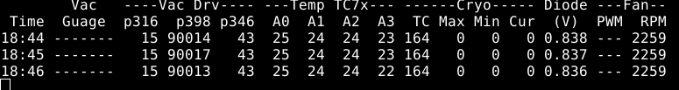

Time - HH:MM based on computer clock. Date not avaliable Gauge - I have no idea

p316 - vac turbo power [W] p398 - vac turbo RPM p346 - turbo motor temperature [C]

A0 - control board temp [C] A1 - Outside air temp [C] A2 - PAX air temp [C]

A3 - Exhaust air temp [C] TC - coold head temp [K] MAX - max allowable cryo power [W]

MIN - min allowable cryo power [W] Cur - current cryo power [W] V - diode voltage [V], (convertible to [K])

PWM - fan pwm [no idea] RPM - fan rpm

~

State bits (from getstate command):

Last 2 bytes are cleared on stable states and rest is OR-ed. That means e.g. if shutdown happened after heating up, but before stable state, state bytes may look like: 0x00003d.

Lack of vac pumping bit means that “autostart” started from cold state T<200. Only 0x10 and 0x80 clean remaining bits. Error bits are only being cleared on reset/restart

0x000000 - not initialized (or manual autostart)

0x000001 - started initialization

0x000002 - started vacuum pumping

0x000004 - init cooling

0x000008 - cooling down - power

0x000010 - cooling down - temp/stable low temp

0x000020 - heating up

0x000040 - switching off

0x000080 - stable high temp (shutdown) state

0x000100 - e000 occurred (auto start init error)

0x000200 - e001 occurred (vac creation)

0x000400 - e002 occurred (vac rot speed error)

0x000800 - e003 occurred (vac power error)

0x001000 - e004 occurred (serious cryo/vac comm error)

0x002000 - e005 occurred (vac rot speed error with cryo running)

0x004000 - e006 occurred (cryo init comm error)

0x008000 - e007 occurred (rot speed on heat-up error)

0x010000 - e008 occurred (cold init error)

0x020000 - e009 occurred (vac cold start error)

0x040000 - e010 occurred (vac rpm oscillation)

0x080000 - e011 occurred (cryo motor temp issue)

0x100000 - temp readout problem (A5/A6)

0x200000 - e012 occurred (cryo down while low temp)

0x400000 - cryo comm problem (timeout)

0x800000 - vac comm problem (timeout)

Because only 2 states clears the full state bits, several other readouts may occur that describe a “partial history” of the feed state. The most valuable information is still stored in the LOG.txt file. So, state - 0x03 means that both initialization and vacuum pumping state started in the past. 0x0f means that feed is being cooled with constant power, 0x1f means the feed is cooling with increasing max power, while 0x10 (all other bits cleared) means that it reached steady state. 0x3f means it started to heat up before reaching the steady state, 0x30 means that it started heating up after reaching steady state, whereas 0x2f means it started heating while in constant power mode.

# Feed Control Board Help Command Examples:

help

SYNOPSIS

help [topic]

DESCRIPTION

shows help information for Antonio feed control board internal commands. Cryo and vacuum controller commands, which pass through the control board, are documented elsewhere.

Commands beginning with a lowercase p and three numbers (e.g., "p316") are routed to the vacuum controller.

Uppercase commands (e.g., "TC") are routed to the cryo controller.

EXAMPLES

list all available internal commands: help commands

show help information for getvacuum command: help getvacuum

help commands

setfanpwm getcryoattemp

getfanpwm getfeedstartmode

getfanrpm -or- getfanspeed setfeedstartmode

gettemp -or- gt

getvacuum -or- gv

getdiode -or- gd

setcryostartmode

getaccel getrelay

setrelay bootloader

minex -or- hyperterminal -or- ht reset

ls -or- dir stty -or- rimbox

cat -or- type getversion

get24v get48v

help getvacuum

SYNOPSIS

getvac [options] gv [options]

DESCRIPTION

get Pfeiffer vacuum gauge reading in millibar units. May also return

"underrange," "overrange," or "sensor error" (see manual).

-v return measured voltage (don't convert to millibar)

EXAMPLES

get vacuum gauge reading converted to millibar units: getvac

get measured vacuum gauge voltage: getvac –v

# How to Connect to Feed Control via the Rim Box:

From ant2e linux command line:

telnet rimbox 1518

The above, will open a connection to the rimbox RS-232 port over which you can talk to the feed controller board. Just like telnet'ing to other boards, you can hit "control-C e " to close the connection.

~

# Feed Control Board Diagram and Photo:

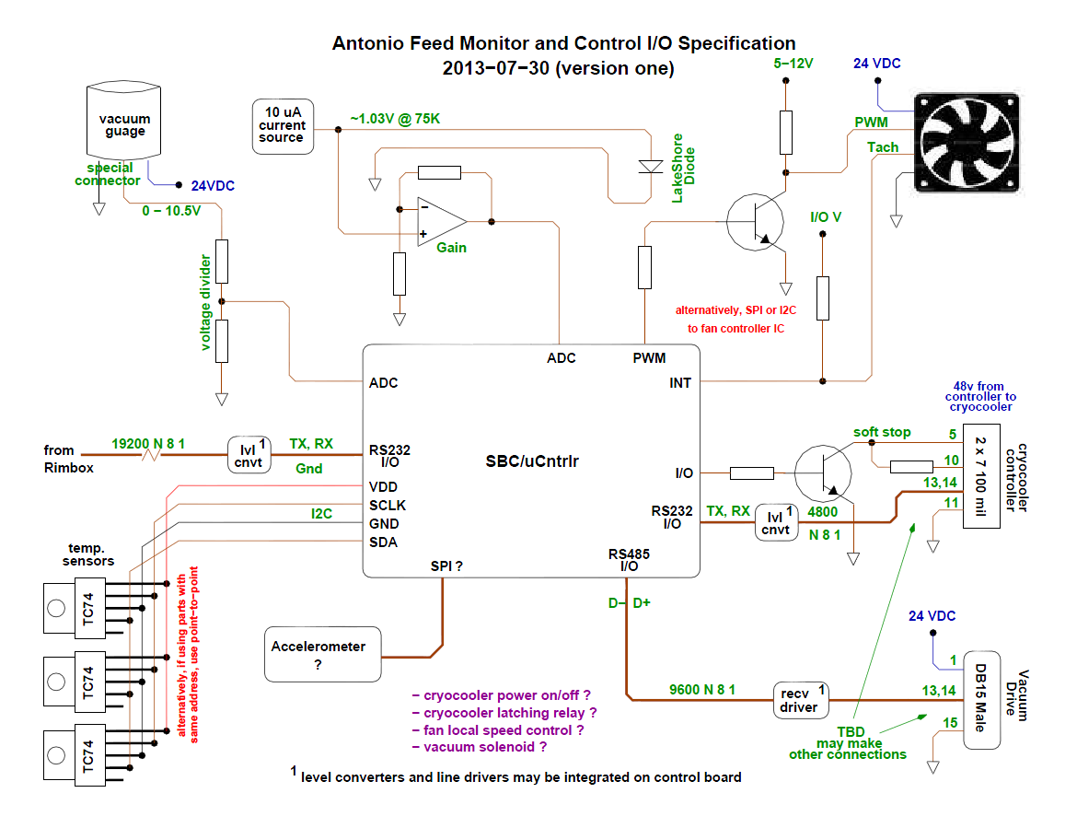

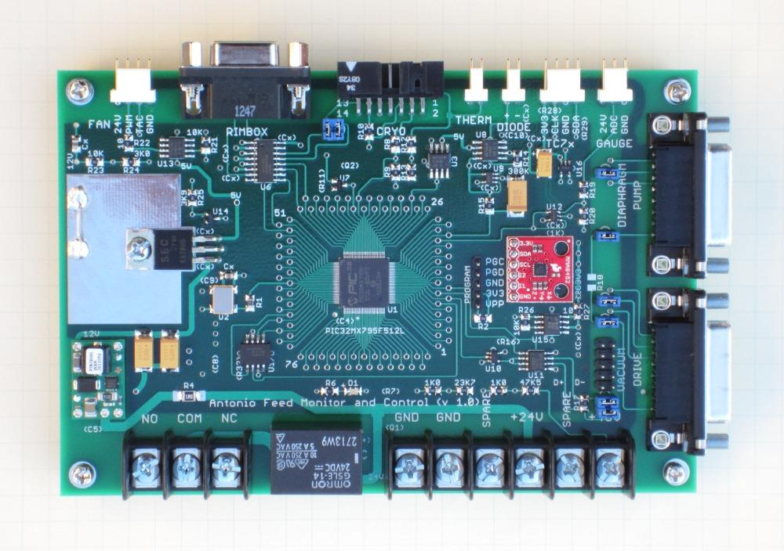

**Appendix A Typical Performance Charts** ( page 1 )

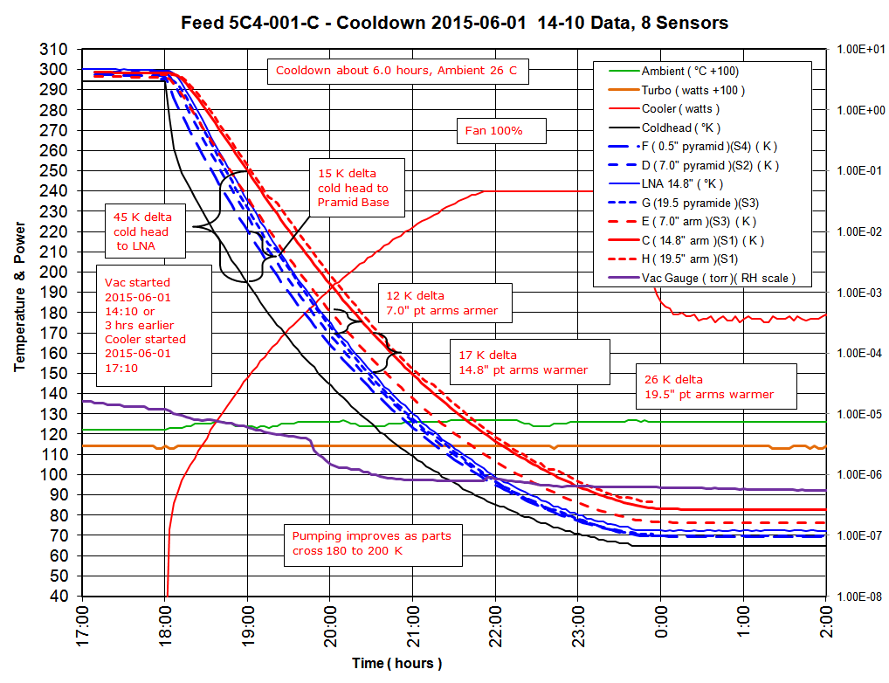

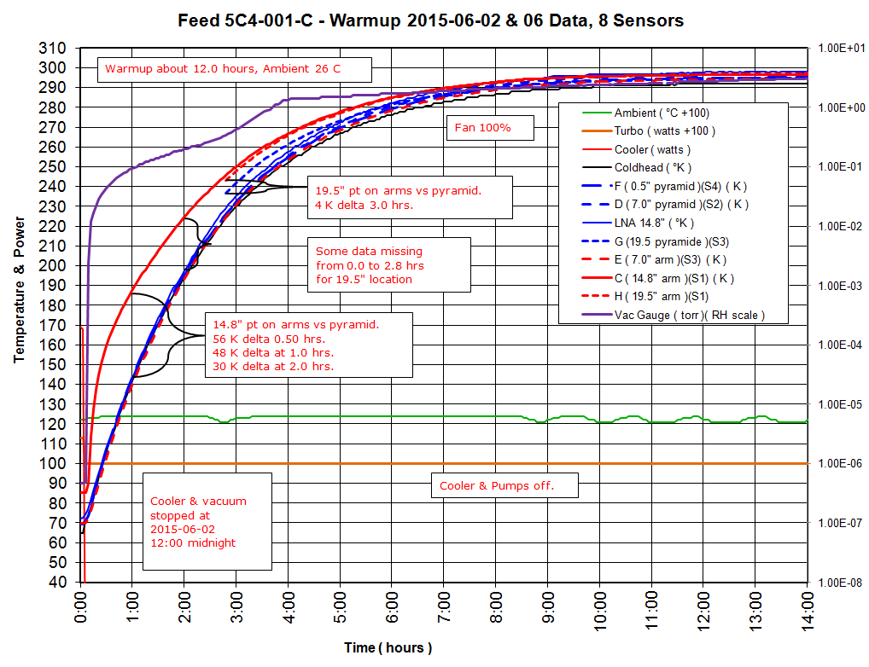

**Appendix A** ( page 2 )

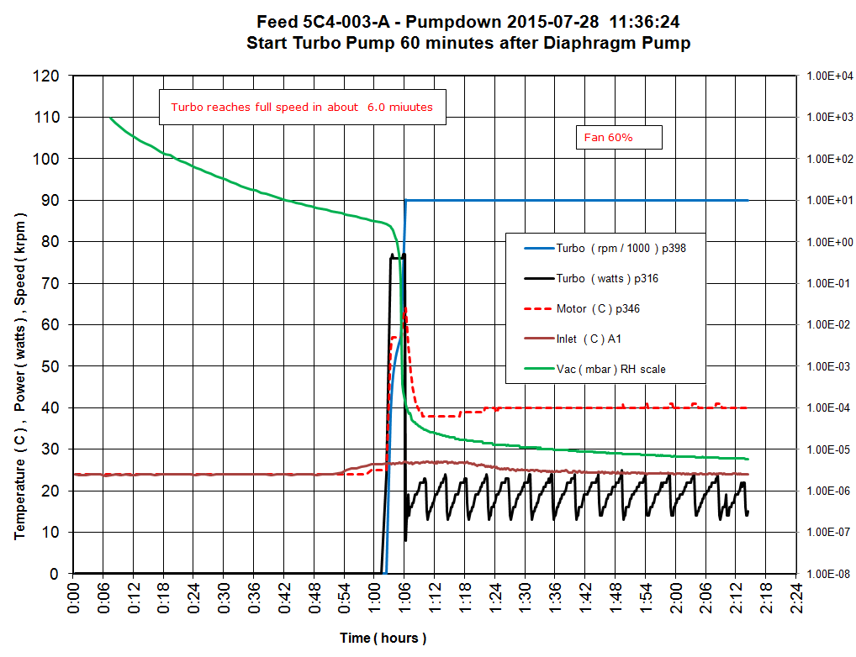

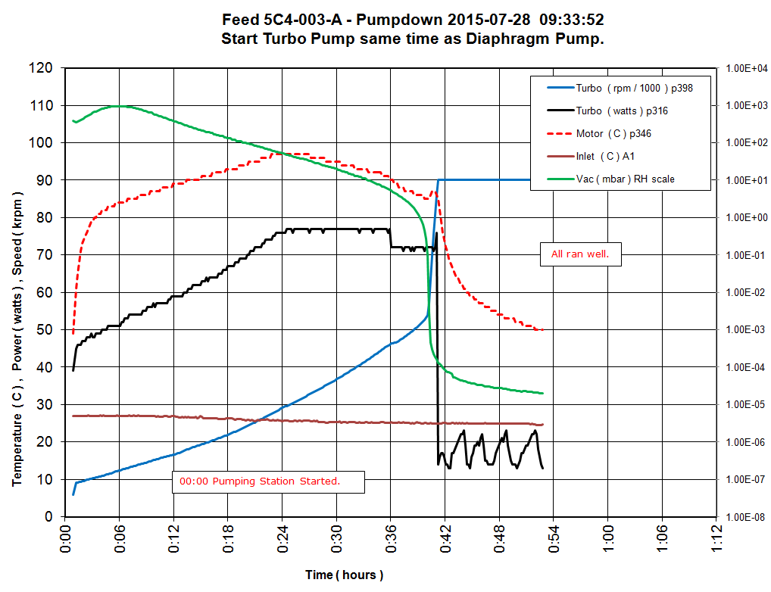

**Appendix B Improvements Needed** ( page 1 )

**This Appendix stores some ideas about maintenance routines. ( not implemented )**

Possible Thermal Control Routine:

Determine current programmed fan speed lower limit Y. ( Y for user input of user defined value )

If cooler rejection temp is > X and T2/T1 > 1, increased fan speed by X%.

If cooler case temp > X and T2/T1 > 1, increased fan speed by X%.

If pump electronics temp > X and T2/T1 > 1, increased fan speed by X%.

If none of the above is true, reduce fan speed by X %, until low speed limit Y is reached.

( evaluate every 10 sec ?? )

If cooler rejection temp exceeds X, turn off cooler and wait X minutes.

If cooler case temp exceeds X, turn off cooler and wait X minutes.

If the above is executed 3 times, stop attempts and send error message.

Other Maintenance Monitoring:

If acceleration exceeds X, send error.

If gauge has been on for more than X hours, turn off. ( relay )

Record data log for period Y in local memory. ( this would give some data to laptop without use of main lab data )

Update most recent maximums or extremes. ( when did it occur ? )

Update fraction of time over period Y that data value exceeded Y.

LNA Temperature Troubleshooting:

Cold Head Temperature strange while LNA Temperature is consistent:

If TC = 400K, the RTD sensor most likely has a broken wire or open circuit.

If TC = 35K then the RTD sensor most likely has a short to ground.

If TC = variable numbers over a short time scale, the RTD may have an cracked wire vibrating at 60Hz.

If TC = Incorrect value the RTD may have a vibrating rub spot where insulation is worn through and grounding.

If TC = variable numbers over a longer time scale, the sensor maybe loose or cooler malfunctioning, check P or E.

~

**Appendix B** ( page 2 )

Other Important Ideas to Implement:

Disable cooler under the following conditions: ( avoid icing and major vibration, hammering, from vacuum loss )

If 24 VDC is not present. Idea: use SET SSTOPM =1, allow pin 5 control, run = pin 5 open or low, stop = pin 5 high to 5V from onboard isolated pin 10 or 12, use relay or IO on Feed Control Board, wiring Feed Board to Cooler Board in existing?

If vacuum is not present. Idea: turbo control status

If air flow is not present. Idea: use temp sensor on cooler, use rpm sensor on fan, hard wire switch to Cooler Control.

Physically move the clamp on Cooler End Pin so it will not hit the cross bar at zero vacuum.

====================================

